**Design Code:**

module FA(input a,b,c, output s,cy);

    assign s = a^b^c, cy = a&&b||a&&c||b&&c;

endmodule

module mux(input a,b,s, output x);

    assign x = s ? b:a;

endmodule

module adder(input [15:0] a,b, input cin, output cout,output [15:0] sum);

    wire [16:0] car_zero,car_one;

    wire [15:0] sum_zero,sum_one;

    genvar i;

    assign car_zero[0] = 1'b0, car_one[0] = 1'b1;

    generate for(i=0;i<16;i=i+1)begin:adder_circ

        FA zero(a[i],b[i],car_zero[i],sum_zero[i],car_zero[i+1]);

        FA one(a[i],b[i],car_one[i],sum_one[i],car_one[i+1]);

        mux opt(sum_zero[i],sum_one[i],cin,sum[i]);

    end endgenerate

    mux (car_zero[16],car_one[16],cin,cout);

endmodule

**Test Bench:**

module tb;

    reg [15:0] a,b;

    reg cin;

    wire cout;

    wire [15:0] sum;

    integer fx,fy1,A;

    adder uut (a,b,cin,cout,sum);

    initial begin

        fx = $fopen("C:\\Users\\User\\Documents\\Code-sync\\M.Tech_Verilog\\Labs\\Read_Write\\test_values.txt", "r");

        fy1= $fopen("C:\\Users\\User\\Documents\\Code-sync\\M.Tech_Verilog\\Labs\\Read_Write\\output_values.txt", "w");

        while (! $feof(fx)) begin

         $fscanf(fx,"%d\n",A);

            a = A;

            $fscanf(fx,"%d\n",A);

            b = A;

            $fscanf(fx,"%d\n",A);

            cin = A;

            #1;

            #1;

            if ({cout,sum} == a+b+cin)begin

                $display("success");

                $fdisplay(fy1,"%d",{cout,sum});

            end

            else $display("failure %d, %d",{cout,sum} ,a+b+cin);

        end

        $fclose(fx);

        $fclose(fy1);

    end

endmodule

**Simulation Result:**

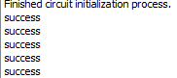

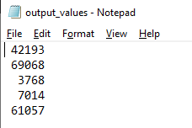

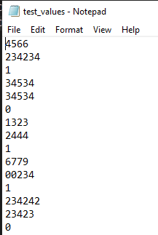

**RTL Diagram:**

